set statistics io on
SELECT SUM(ISNULL( EA_POS.QT_EMPRESTIMO,0 )) QTD_EMPRESTIMO FROM SAC_RV_EM_POS EA_POS, SAC_RV_EMPRESTIMO_ACOES EA_MOV WHERE EA_POS.ID_MOVIMENTO = EA_MOV.ID_MOVIMENTO AND EA_POS.DT_POSICAO = '1-2-2012 0:0:0.000' AND EA_MOV.CLCLI_CD = '3061' AND EA_MOV.RVPAP_CD = 'CMIG4' AND EA_MOV.SG_OPERACAO IN ('E', 'R', 'P') AND EA_MOV.IC_TIPO_MOVIMENTO = 'T'
set statistics io off

--Table 'SAC_RV_EM_POS'. Scan count 1, logical reads 3

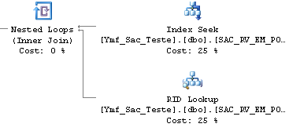

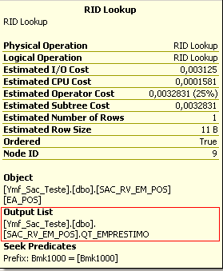

USE [Ymf_Sac_Teste]
GO
/****** Object: Index [XPK_SAC_RV_EM_POS] Script Date: 01/11/2012 11:57:57 ******/
ALTER TABLE [dbo].[SAC_RV_EM_POS] ADD CONSTRAINT [XPK_SAC_RV_EM_POS] PRIMARY KEY CLUSTERED –(The Table don’t have clustered index)
(
[DT_POSICAO] ASC,
[ID_MOVIMENTO] ASC
)WITH (SORT_IN_TEMPDB = OFF, IGNORE_DUP_KEY = OFF, ONLINE = OFF) ON [PRIMARY]

The execution Plan has changed to:

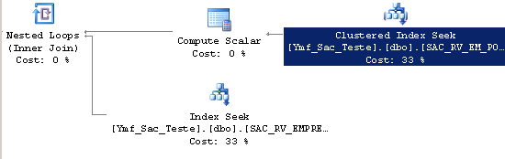

The logical reads between the queries has been the same because SQL SERVER in fact needed to read just 3 Data pages from the Buffer Cache.

-- Table 'SAC_RV_EM_POS'. Scan count 1, logical reads 3

